LPG Gas Leakage Detection

IoT mini-project report submitted in partial fulfilment of the requirements of the degree of

### Bachelor of Engineering (B.E.)

in

### INFORMATION TECHNOLOGY

by

|  |  |
| --- | --- |
| **Nupur Thakur** | **EU1214011 (57)** |
| **Richya Patil** | **EU1214016 (42)** |
| **Pavan Shinde** | **EU1214034 (53)** |
| **Vishruti Sankhe** | **EU1214058 (52)** |

Under the guidance of

**Mr. Sachin Sase** Assistant Professor



### Department of Information Technology

**St. John College of Engineering and Management, Palghar**

2024-2025

**Autonomous Institute Affiliated to University of Mumbai**

**CERTIFICATE**

This is to certify that the IoT mini-project entitled **“LPG Gas Leakage Detection with SMS Alert”** is a bonafide work of **“Nupur Thakur” (EU1214011) (57), “Richya Patil” (EU1214016) (42), “Pavan Shinde” (EU1214034) (53) & “Vishruti Sankhe” (EU1214058) (52)** submitted to University of Mumbai in partial fulfilment of the requirement for the award of the degree of **“Bachelor of Engineering”** in **“Information Technology”** during the academic year 2024–2025.

**Mr. Sachin Sase**

Guide

|  |  |
| --- | --- |
| **Dr. Arun Saxena** | **Dr. Kamal Shah** |
| Head of Department | Principal |

ii

# IoT Project Report Approval

This mini-project synopsis entitled ***LPG Gas Leakage Detection with SMS Alert*** by ***Nupur Thakur, Richya Patil, Pavan Shinde & Vishruti Sankhe*** is approved for the degree of ***Bachelor of Engineering*** in ***Information Technology Engineering*** from ***University of Mumbai***.

**Examiners**

1.

2.

Date:

Place:

# Declaration

We declare that this written submission represents our ideas in our own words and where others ideas or words have been included, we have adequately cited and referenced the original sources. We also declare that we have adhered to all principles of academic honesty and integrity and have not misrepresented or fabricated or falsified any idea/data/fact/source in our submission. We understand that any violation of the above will be cause for disciplinary action by the Institute and can also evoke penal action from the sources which have thus not been properly cited or from whom proper permission has not been taken when needed.

Signature

Nupur Thakur (EU1214011)

--------------------------------------

Signature

Richya Patil (EU1214016)

Signature

Pavan Shinde (EU1214034)

Signature

Vishruti Sankhe (EU1214058)

Date:

## Abstract

*This project focuses on the design and implementation of an Arduino-based Gas Leakage Detector System, integrated with an automatic regulator control and SMS alert feature. Liquefied Petroleum Gas (LPG) is commonly used as a clean fuel for cooking, heating, and industrial purposes. However, gas leakage can lead to severe accidents and hazards, posing a serious risk in both residential and industrial settings. The proposed system uses gas sensors to detect any leakage of LPG and immediately triggers an alarm, sends an SMS alert to the user, and automatically turns off the gas regulator to prevent further leakage. By providing real-time alerts and taking automatic control of the regulator, this system aims to enhance safety by ensuring prompt action when gas leakage is detected.*

***Keywords—*** *Arduino, Gas Leakage Detection, LPG, SMS Alert, Regulator Control, Gas Sensors,*

*Real-time Monitoring, Alarm, Automation.*

## Table of Contents

|  |  |  |
| --- | --- | --- |
|  | **Abstract** | **v** |
| **List of Figures**  **List of** **Abbreviations** | **Vii**  **viii** |
| **Chapter 1** | **Introduction** | **1** |
|  | 1.1 Motivation | 1 |
|  | 1.2 Problem Statement | 1 |
|  | 1.3 Objectives | 2 |
|  | 1.4 Scope | 2 |
| **Chapter 2** | **Review of Literature** | **3** |
|  | 2.1 LPG GAS LEAKAGE SENSOR WITH SMS ALERT | 3 |
|  | 2.2 SMS Based LPG Gas Leakage Detection System Using GSM | 3 |
|  | 2.3 GAS LEAKAGE DETECTOR SYSTEM WITH SMS ALERT | 4 |
|  | 2.4 LPG Leakage and Flame Detection with SMS Notification and Alarm System | 4 |
|  | 2.5 Intelligent LPG Gas Leak Detection Tool with SMS Notification | 4 |
| **Chapter 3** | **Requirement Analysis** | **5** |
|  | 3.1 Hardware and Software Requirements | 5 |
|  | 3.2 Working Diagram | 6 |
| **Chapter 4** | **Report on Present Investigation** | 7 |
|  | 4.1 Proposed System | 7 |
|  | 4.1.1 Block diagram of Proposed System | 7 |
|  | 4.2 Implementation | 8 |
|  | 4.2.1 Pseudo code | 8 |
|  | 4.2.2 Screenshots of the output with description | 10 |
| **Chapter 5** | **Technologies Used** | 11 |
| **Chapter 6** | **Results and Discussion** | 12 |
| **Chapter 7** | **Conclusion** | 13 |
|  | **References** | 14 |
|  | **Acknowledgement** | 15 |

|  |  |  |
| --- | --- | --- |
| **Figure No.** | **Figure Name** | **Page No.** |
| 4.1.1 | Proposed System | 7 |
| 4.1.2 | Working Diagram | 6 |

**List Of Figures**

**List of Abbreviations**

**SJCEM**  St. John College of Engineering and Management

**IOT** Internet Of Things

**GSM**  Global System for Mobile Communication

**Chapter 1**

**Introduction**

Gas leakage is a serious concern, especially when dealing with LPG, which is highly flammable. LPG is used in millions of households and industries, making it vital to have safety measures in place. Leaking gas can lead to explosions, fires, or poisoning if not addressed quickly. This project aims to mitigate these dangers by creating an Arduino-based Gas Leakage Detector System that can automatically turn off the gas regulator when leakage is detected, in addition to sounding an alarm and sending an SMS alert. The system offers an effective way to prevent accidents by stopping the gas flow at its source and alerting users remotely to the danger.

### Motivation

* Safety risks posed by LPG gas leakage in residential and industrial environments.
* The need for a system that can automatically control gas regulators during leakage.
* The importance of providing immediate alerts through SMS to users.
* The desire to prevent gas-related accidents through proactive technology.

### Problem Statement

Gas leakage from LPG cylinders is a major safety hazard in homes and industries, as it can lead to fires, explosions, or poisoning. Many places still rely on outdated methods like manual checks or human senses, which are slow and unreliable. Even when systems are in place to detect gas, they usually just sound an alarm, requiring people to act manually to turn off the gas. A better solution is needed—one that not only detects the leak but also automatically shuts off the gas and sends alerts to users, ensuring faster response and preventing accidents.

### Objectives

* + - Design and implement an Arduino-based system to detect gas leakage.
    - Automatically control the gas regulator by turning it off during gas leakage.
    - Sound an alarm when gas leakage is detected.
    - Send SMS alerts to notify the user about the leakage in real-time.
    - Provide a reliable, proactive solution for enhancing safety in homes and industries.

### Scope

The scope of this project includes the development of a sensor-based gas leakage detection system that provides multiple layers of safety measures. It can be applied in homes, commercial kitchens, industries, and vehicles where LPG gas is used. The system automatically turns off the gas regulator upon leakage detection, triggers an alarm, and sends an SMS alert to the user. This system can be further expanded by integrating additional sensors or features for wider applications.

## Chapter 2

## Review of Literature

|  |  |  |  |  |
| --- | --- | --- | --- | --- |
| **Sr.**  **No.** | **Paper Title [Ref.]** | **Author names** | **Conclusion** | **Research Gaps** |
| 1. | LPG GAS LEAKAGE SENSOR WITH SMS ALERT  Journal Name:  IRJMETS  Year: April 2023 | Varad Dixit, Digvijay Deshmukh | The LPG gas leakage sensor offers a fast, accurate, and cost-effective solution for detecting gas leakage, helping to prevent accidents in both domestic and industrial settings. | Further exploration is needed to improve the sensor's durability and integration with smart home systems for enhanced safety. |
| 2. | SMS Based LPG Gas Leakage Detection System Using GSM  Journal Name:  IJRES Year: April 2022 | Lokhande Ankita , Pandhare Komal , Shinde Akash Ram | The LPG Gas Detection System using a GSM module successfully detects gas leaks, automatically cuts off the power supply, and alerts the user, preventing accidents efficiently. | Further work is needed to refine the system's design and develop a working model for real-world applications. |

Table 2.1. Literature Survey

3

|  |  |  |  |  |
| --- | --- | --- | --- | --- |
| **Sr.**  **No** | **Paper Title**  **[Ref.]** | **Author names** | **Conclusion** | **Research Gaps** |
| 3. | GAS LEAKAGE DETECTOR SYSTEM WITH SMS ALERT  Journal Name:  Global Scientific  Year: October 2021 | Nwukor Frances Nkem | A gas leakage detection and alert system was successfully developed, which detects LPG leaks and prevents further leakage while sending alerts via SMS. | Future work could explore improving sensor sensitivity under varying environmental conditions, such as temperature, and enhancing the system's response time at greater distances from the gas source. |
| 4. | LPG Leakage and Flame Detection with SMS Notification and Alarm System  Journal Name:  Research Gate  Year: April 2020 | Luisito Lolong Lacatan, Rhowel Dellosa | The device developed for detecting gas, smoke, and flame from LPG cylinders is highly accurate and reliable, ensuring the safety of consumers by notifying them via text messages and an alarm system. | The study doesn't explore integrating advanced features like real-time monitoring through mobile apps or the use of machine learning to improve detection capabilities. |
| 5. | Intelligent LPG Gas Leak Detection Tool with SMS Notification  Journal Name:  Research Gate  Year: December 2019 | Muhammad Siddik Hasibuan, Iswandi Idris | This system effectively detects LPG gas leaks within a 50-80 cm radius using an MQ-2 sensor, alerts users via an alarm, and sends SMS notifications, enhancing safety and comfort. | Future research could focus on increasing the detection range and improving real-time data communication methods. |

Table 2.1. Literature Survey

4

## Chapter 3

**Requirements Analysis**

### Requirement Analysis



### Hardware Requirements

|  |  |
| --- | --- |
| **Hardware** | **Cost** |
| Arduino UNO R3 | 450 Rs |
| LCD Display | 130 Rs |
| LM2596 dc converter | 100 Rs |
| Jumper Wires | 146 Rs |
| Servo Motor | 180 Rs |
| LEDs | 100 Rs |
| Mq5 sensor | 200 Rs |
| GSM Module | 330 Rs |
|  | **Total:- 1636 Rs** |

### Software Requirements

* + - * + Arduino IDE

5

5

**3.2 Working Diagram**

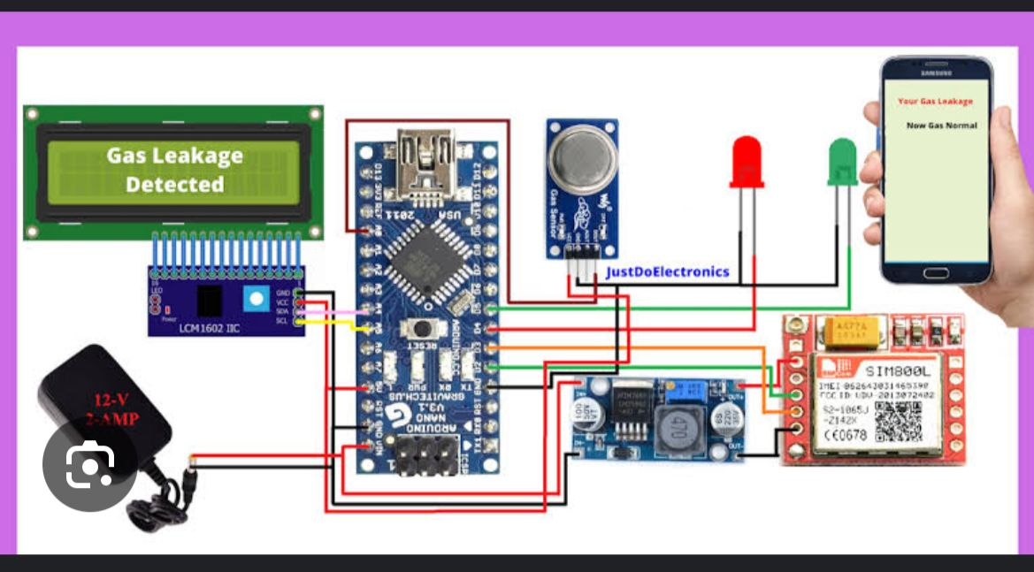

6

## Chapter 4

**Report on Present Investigation**

### Proposed System

* + 1. **Block diagram of Proposed System**

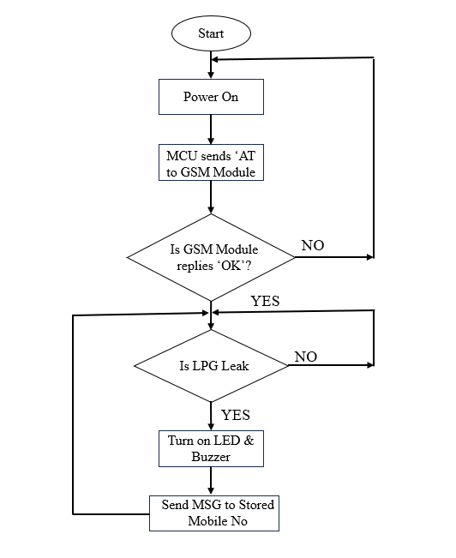

Servo motor turn on/off

Fig.4.1.1. Proposed System

7

### Implementation

### Pseudo Code

#include <LiquidCrystal_I2C.h>

#include <Servo.h> // Include Servo library

#include <SoftwareSerial.h> // Include SoftwareSerial for GSM

LiquidCrystal_I2C lcd(0x27, 16, 2); // Initialize LCD with I2C address

SoftwareSerial mySerial(9, 10); // RX, TX for SoftwareSerial (GSM module)

Servo myServo; // Create a Servo object

int buzzer = 11;

int GASA0 = A0; // Gas sensor pin

int gasvalue;

int baseline = 100; // Adjust this after calibration

int threshold = 10; // DANGER threshold (set at 10%)

int numReadings = 10; // Number of readings to average out

int servoPin = 6; // Pin for the servo motor

bool smsSent = false; // Flag to track if SMS has been sent

void setup() {

lcd.init(); // Initialize the LCD

lcd.backlight();

mySerial.begin(9600); // Begin SoftwareSerial communication (GSM module)

Serial.begin(9600); // Begin hardware serial communication

pinMode(buzzer, OUTPUT); // Set buzzer as output

lcd.setCursor(3, 0); // Set cursor on LCD

lcd.print("welcome"); // Display welcome message

delay(2000);

myServo.attach(servoPin); // Attach the servo motor to the specified pin

myServo.write(0); // Initialize servo at 0 degrees (regulator OFF position)

initializeGSM(); // Initialize GSM module

}

void loop() {

int total = 0;

int avgReading = 0;

// Take multiple readings and average them out to reduce noise

for (int i = 0; i < numReadings; i++) {

total += analogRead(GASA0);

delay(50); // Short delay between readings

}

8

avgReading = total / numReadings; // Average the sensor readings

// Print the raw averaged sensor value for debugging

Serial.print("Average sensor value: ");

Serial.println(avgReading); // Print averaged value to the Serial Monitor

// Calibrate the sensor reading by subtracting the baseline

gasvalue = (avgReading - baseline) / 10;

lcd.clear(); // Clear the LCD display

lcd.setCursor(0, 0);

lcd.print("GAS Level:");

lcd.setCursor(10, 0);

lcd.print(gasvalue); // Display gas level on LCD

lcd.print("%");

// Check if gas level has reached the threshold of 10%

if (gasvalue >= threshold) {

// No buffer, gasvalue should be >= 10%

lcd.setCursor(0, 1);

lcd.print("DANGER"); // Display danger warning

tone(buzzer, 1000); // Activate the buzzer

// Turn on servo to simulate turning off the regulator

myServo.write(90); // Move servo to 90 degrees to "turn off" the regulator

lcd.clear();

lcd.setCursor(0, 1);

lcd.print("Turn off regulator"); // Display the message

// Send SMS only once

if (!smsSent) {

SendTextMessage();

smsSent = true; // Prevent sending multiple SMSs

}

} else {

lcd.setCursor(0, 1);

lcd.print("NORMAL"); // Display normal status

noTone(buzzer); // Stop the buzzer

// Reset the servo motor back to 0 degrees when gas level is normal

myServo.write(0); // Move servo back to 0 degrees (default position)

smsSent = false; // Reset SMS sent flag when back to normal

}

delay(500); // Delay to avoid frequent updates

}

// Initialize the GSM module

void initializeGSM() {

Serial.println("Initializing GSM module...");

mySerial.println("AT"); // Check if GSM module is responding

delay(1000);

9

mySerial.println("AT+CMGF=1"); // Set SMS to text mode

delay(1000);

mySerial.println("AT+CSCS=\"GSM\""); // Set character set to GSM

delay(1000);

Serial.println("GSM module initialized.");

}

// Function to send an SMS when gas level is dangerous

void SendTextMessage() {

Serial.println("Sending SMS...");

mySerial.println("AT+CMGF=1"); // Set SMS text mode

delay(1000);

mySerial.println("AT+CMGS=\"+1234567890\""); // Replace with your phone number

delay(1000);

mySerial.print("WARNING: Gas leakage detected! Turn off the regulator immediately.");

delay(1000);

mySerial.write(26); // Ctrl+Z character to send the message

delay(1000);

Serial.println("SMS sent.");

}

### Screenshot of Output

10

**Chapter 5**

**Technologies Used**

* 1. **Technologies Used**

**GSM 800L Module:** The GSM 800L module is a small device that allows communication over mobile networks. It can send and receive text messages and make phone calls. It's often used in projects like remote monitoring, home automation, and IoT applications. The module connects to a microcontroller, like an Arduino, and requires a SIM card to operate. It's popular because it’s easy to use and provides reliable mobile connectivity.

**ChatGPT :-** ChatGPT is an AI chat tool designed to talk with you. It can answer questions, provide information, and help with tasks like writing or brainstorming ideas. It learns from a lot of text, so it can chat about various subjects and adapt to your style. It's like having a conversation with a helpful virtual assistant!

**Arduino IDE :-** The Arduino Integrated Development Environment - or Arduino Software (IDE) - contains a text editor for writing code, a message area, a text console, a toolbar with buttons for common functions and a series of menus. It connects to the Arduino hardware to upload programs and communicate with them.

## 

11

## Chapter 6

**Result and Discussion**

The designed system was able to detect LPG leakage promptly using gas sensors. Upon detection, the system successfully turned off the gas regulator using a Servo motor, preventing further gas leakage. The buzzer alarm worked as expected, providing an immediate auditory alert, while the SMS feature sent notifications to the user’s phone. By combining these features, the system provides a robust solution for mitigating the risks associated with gas leakage. The automatic regulator control adds an important safety measure by stopping gas flow in real-time. The performance of the system was evaluated in various scenarios, and it consistently detected gas leakage and activated all safety features. The SMS alert system was also tested to ensure notifications were sent without delay, ensuring users are informed in real-time

12

## Chapter 7

**Conclusion**

The Arduino-based Gas Leakage Detector System offers an effective and proactive solution for managing LPG gas leakage risks. By incorporating automatic regulator control, alarm triggers, and SMS notifications, the system enhances safety in both residential and industrial settings. It provides real-time alerts and takes immediate action to prevent accidents, making it a practical and reliable solution for mitigating the dangers associated with gas leakage. The system can be further improved with additional features or expanded to other areas where gas safety is critical.

13

### References

[1] “LPG GAS LEAKAGE SENSOR WITH SMS ALERT”, Varad Dixit, Digvijay Deshmukh, IRJMETS, April 2023.

[2] “SMS Based LPG Gas Leakage Detection System Using GSM”, Lokhande Ankita , Pandhare Komal, IJRES, April 2022.

[3] “GAS LEAKAGE DETECTOR SYSTEM WITH SMS ALERT”, Nwukor Frances Nkem, Global Scientific, October 2021.

[4] “LPG Leakage and Flame Detection with SMS”, Rhowel Dellosa, Research Gate, April 2019.

[5] “Intelligent LPG Gas Leak Detection Tool with SMS Notification”, Iswandi Idris, Research Gate, December 2019.

14

### Acknowledgement

We owe our deepest gratitude and regards towards the ones who offered their valuable guidance in the hour of need. We thank our guide **Mr. Sachin Sase** **(Assistant Professor, Department of Information Technology, St. John College of Engineering and Management)** for her guidance and precious insights. Her useful comments and feedbacks during the discussions we had and the encouragement to question every technical detail that we came across while partially completing this B.E. project helped us to a great extent. We also take the opportunity to thank Mr. Sachin Sase (IoT Project Co-Ordinator) and **Dr.** **Arun Saxena (Head of Department)** who have always rendered their support and assistance in the best possible way. We would also like to thank **Dr. Kamal** **Shah (Principal, St. John College of Engineering and Management)** and the members of Aldel Education Trust who have given us the background to conduct this B.E project

15